**NOTES:**

* LEDs count to 7 bits

1. push ax  
2. push ds  
3. push dx  
4. mov dx, $379  
5. in al, dx  
6. mov ax, seg counter  
7. mov ds, ax  
8. inc counter  
9. mov al, EOI  
10. out PIC, al  
11. pop dx  
12. pop ds  
13. pop ax  
14. iret

P1Q1. Comment the provided assembly code shown above from the ISR of LAB2A.pas. Explain the necessity/role of each line in the overall functionality of the ISR. Use your own words and do not include the comments already provided in the .pas file *

P1Q2. Upload a screenshot with timing from the interrupt request signal (IRQ7) to the first visible marker in the ISR. *

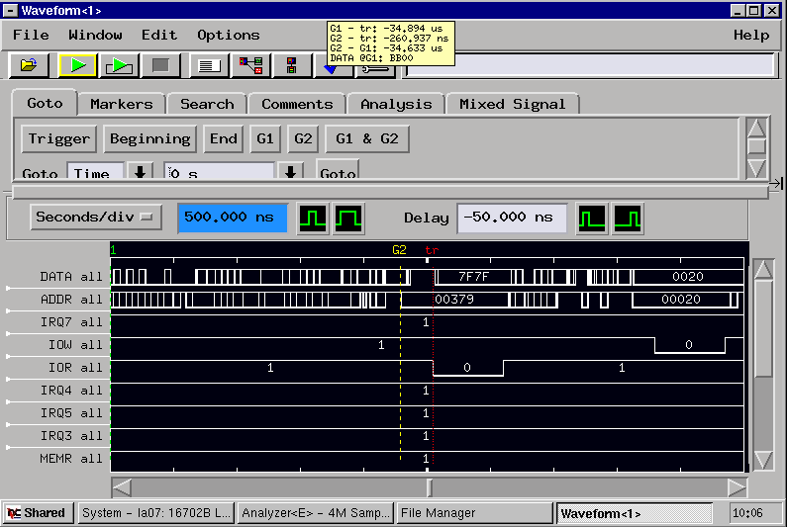

P1Q3. Upload a screenshot with timing between two visible markers in the ISR. *

P1Q4(a). Calculate the full interrupt service time (i.e time from interrupt request signal to ISR end) in microseconds and enter the result of your calculations below. Hint: There are few instructions at the end of the ISR that were not included in your timing but can be taken into account knowing the SYSCLK frequency. *

P1Q4(b). Explain how you calculated the full interrupt service time. *

P1Q5(a). Explain what you observed when the square wave frequency was increased. *

* The LEDS glitched tf out

P1Q5(b). Upload a screenshot showing how the system malfunctioned when the square wave frequency was increased. *

P1Q5(c). At what square wave frequency did the system start to malfunction? Give your answer in MHz. *

* 40 KHz

P1Q5(d). Explain how the system malfunctions at and above that frequency. *

* Stops visibly counting, looks more like a wave of lights – gets worse, IRQ7 triggers but doesn’t read or write because its occurring too fast

P1Q6(a). Why would someone enable interrupts inside an ISR? *

P1Q6(b). How can a system fail if interrupts are enabled inside an ISR? *

P1Q7. How can you decrease the latency of the ISR in the LAB2A? *

PART 2 OF THE LAB

P2Q1. Upload a completed LAB2B code fully commented in .txt format. Explain the necessity/role of each line in the overall functionality of the program. Use your own words and do not include the comments already provided in the .pas file. *

P2Q2(a). Briefly explain the following parameter of the serial port setup: "Baud Rate". *

P2Q2(b). Briefly explain the following parameter of the serial port setup: "Data Bit". *

P2Q2(c). Briefly explain the following parameter of the serial port setup: "Stop Bit". *

P2Q2(d). Briefly explain the following parameter of the serial port setup: "Parity". *

P2Q3(a). In serial communication, what are some symptoms of sending bits too fast? *

(b). In serial communication, what are RTS and CTS hardware flow control mechanisms? *

P2Q4(a). Search about the Line Status Register (LSR) of the serial communication, and briefly, explain bit 0 of the LSR. *

P2Q4(b). Search about the Line Status Register (LSR) of the serial communication, and briefly, explain bit 1 of the LSR. *

P2Q4(c). Search about the Line Status Register (LSR) of the serial communication, and briefly, explain bit 2 of the LSR. *

P2Q4(d). Search about the Line Status Register (LSR) of the serial communication, and briefly, explain bit 3 of the LSR. *

P2Q4(e). Search about the Line Status Register (LSR) of the serial communication, and briefly, explain bit 4 of the LSR. *

P2Q4(f). Search about the Line Status Register (LSR) of the serial communication, and briefly, explain bit 5 of the LSR. *

P2Q4(g). Search about the Line Status Register (LSR) of the serial communication, and briefly, explain bit 6 of the LSR. *

P2Q4(h). Search about the Line Status Register (LSR) of the serial communication, and briefly, explain bit 7 of the LSR. *